Project Design Phase-II

Data Flow Diagram & User Stories

Date | 01 Feb 2026
Team ID | LTVIP2026TMIDS89610
Project Name | Empowering India: Analysing the evolution of union budget allocations for sustainable growth
Marks | 3 Marks

Data Flow Diagrams:
A Data Flow Diagram (DFD) is a traditional visual representation of the information flows within a system. A neat and clear DFD can depict the right amount of the system requirement graphically. It shows how data enters and leaves the system, what changes the information, and where data is stored.

Example: (Simplified)
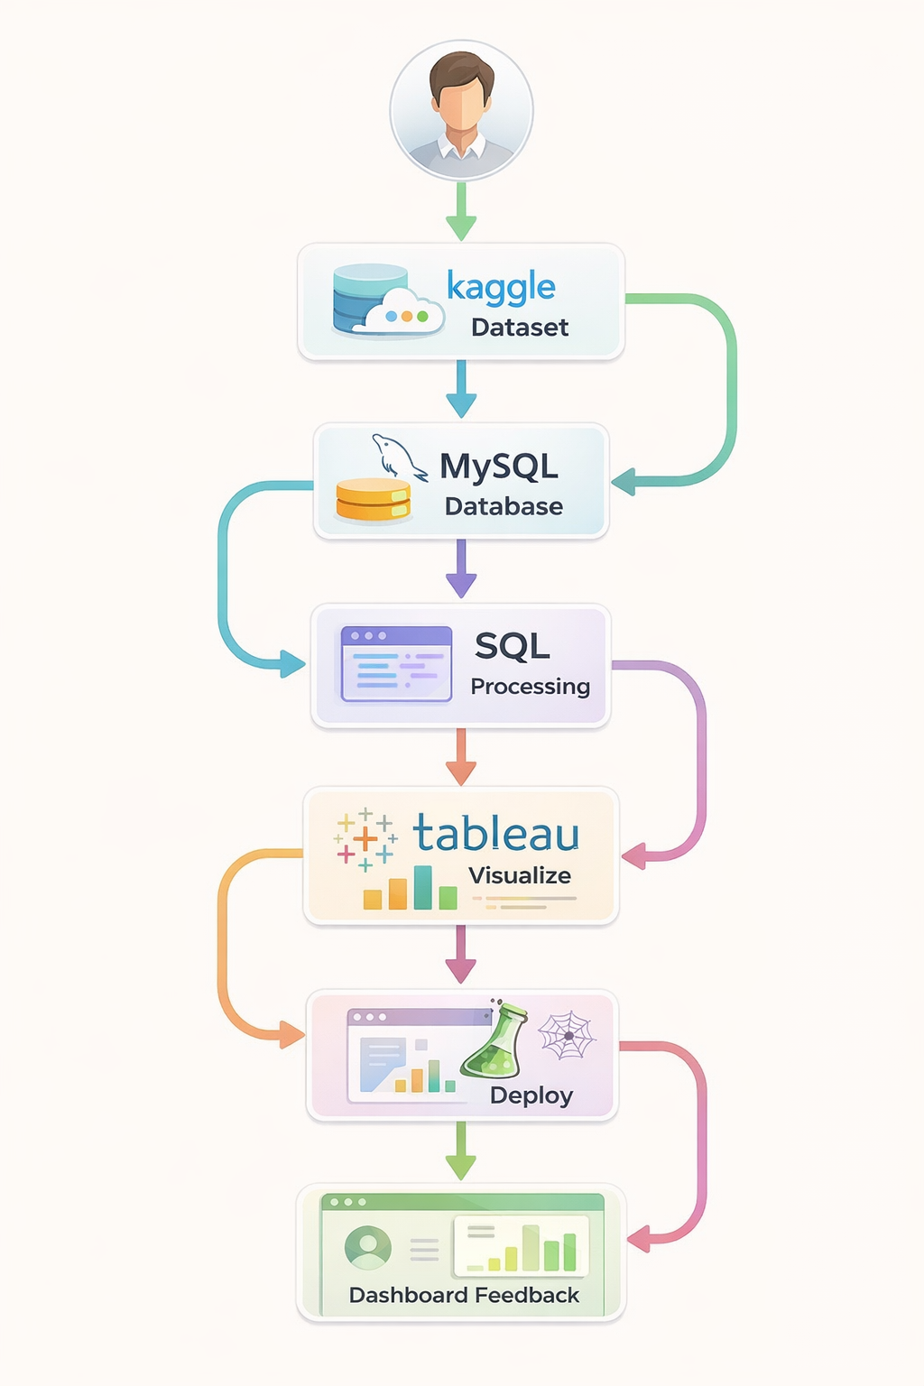

User Stories

User Type | Functio nal Require ment  (Epic) | User Story Number | User Story / Task | Acceptance Criteria | Priority / Release
Policy Analyst | Data Upload & Integration | USN-1 | As a Policy Analyst, I can upload Union Budget datasets (2021–2024) into the system for analysis. | Dataset successfully uploaded, validated, and stored in database. | High / Sprint-1
Data Analyst | Dashboard Visualization | USN-2 | As a Data Analyst, I can view category-wise, ministry-wise, and scheme-wise budget allocations in Tableau dashboards. | Visualizations load correctly with filters working properly. | High / Sprint-1
Government Official (End User) | Budget Comparison | USN-3 | As a Government Official, I can compare Actual, Estimated, and Revised Budget values across financial years. | Comparison charts display accurate year-wise values. | High / Sprint-2
Researcher | Trend Analysis | USN-4 | As a Researcher, I can analyze budget allocation trends over multiple years to identify growth patterns. | Trend line graphs correctly represent year-wise changes. | Medium / Sprint-2
Business Stakeholder | Report Generation | USN-5 | As a Business Stakeholder, I can download summary reports of budget insights for decision-making. | Report is generated accurately and downloadable in PDF format. | Medium / Sprint-3
Administrator | Data Management | USN-6 | As an Administrator, I can manage datasets, update records, and maintain database integrity. | Data updates reflect correctly without errors. | High / Sprint-1

